caBIG

Test Automation Plan

Document Change History
Version Number | Date | Contributor | Description
V0.1 | 6/24/2010 | Jim Jones | First Draft


Updated September 16, 2010
Table of Contents

1 Introduction 2
1.1 Project Overview 2
1.2 System Overview 2
1.3 Document Overview 2
1.4 Relationship to Other Documents/Plans 2
1.5 Assumptions 2
1.6 Constraints 2
2 Automation Tool Categories 3
2.1 Test Management 3
2.2 Functional Testing 3
2.3 Performance Testing 3
2.4 Integration for Traceability 3
2.5 Continuous Integration 4
3 Proposed Implementation 4
4 Test Management Tool Evaluation 4
5 Functional Test Tool Evaluation 5
5.1 Webservices Operations Testing 5
5.2 Serialization/Deserialization Testing 6
6 Performance Testing 6
6.1 Scenario Design and Scripting 7
6.2 Cloud Infrastructure 7
6.3 Test Environment Provisioning 7
6.4 Monitoring 7
7 Integration for Traceability 8
7.1 Traceability to Requirements 8
7.2 Traceability to Defects 8
8 Continuous Integration 9
8.1 Service Test tests hosted in Quality Center 9
8.2 JUnit Tests 9

Introduction
This test automation plan describes the selection and planned implementation of tooling to support the Quality Assurance and Testing activities of the Center for Biomedical Information and Information Technology (CBIIT) Ambulatory Oncology Electronic Health Record (caBIG) project.

Project Overview
The goal of the caBIG project is to support the Ambulatory Oncology sector, in the delivery of improved patient care through the development of consensus based health IT standards and solutions that meets this sector unique EHR needs.

System Overview
The caBIG project will develop service specifications that will be adopted in the Ambulatory Oncology sector to meet the unique EHR needs of that sector to provide improved patient care.

Document Overview
This Test Automation Plan explain the evaluation process, status and proposed implemenation for the toolset proposed to support all QA testing activities.

Relationship to Other Documents/Plans

This plan references the following Plans:
Performance Test Plan

Assumptions
At the onset of the project there was not enough time to do a protracted tool selection. The HP Test Suite was included in the proposal so it was assumed that this suite would meet our needs. The QA Team proceeded to evaluate the toolset with special focus on its operation in acloud environment and its integration with tools selected by other teams.

Constraints
JIRA Studio was immediately selected and implemented by the ESD Team. Integration of the QA toolset with JIRA Studio was therefore a constraint.
JAMA Contour was selected by the Analysis Team as their Requirements Management tool. Integration of the QA toolset with Contour was therefore a constraint.

Automation Tool Categories

Test Management
A test management tool is the central tool for the QA Team to perform all of its basic tasks:
Design test cases
Execute test cases
Report/track defects
Assure requirements traceability/coverage
Report test metrics

HP Quality was evaluated and selected as the QA Team test management tool.

Functional Testing
In its functional test automation approach the QA Team considered that converage was required not only for the webservice operations but also for the serialization/deserialization into and out of XML. The last part was imperative because the caBIG webservices are not being developed for use in reference implementation. QA therefore considered the following “headless” clients for test of webservice operations at the XML request/response level:
Service Test
SoapUI

Service Test was selected by the QA Team because of its integration with Quality Center
QA will augment its functional automation with a Java-based programmatic appoach based on the JUnit test framework. This will incorporate a Java webservices client which will test serialization/deserialization.

Performance Testing
A performance test tool is required to execute webservice operations in sufficient numbers and in a controlled fashion to measure the webservice’s responsiveness. LoadRunner and Neoload were evaluated for the purpose. LoadRunner was selected because of its reuse of the Service Test functional test scripts and its integration with Quality Center.

Integration for Traceability
Due the the constraints noted above, it was necessary to evaluate and assure that QA had a reliable way to integrate with the ESD and Analysis toolsets. JIRA Bridge was evaluated and selected for integration of defects between Quality Center and JIRA Studio. Contour/QC Integration was evaluated and selected for integrating requirements between Quality Center and Contour.

Continuous Integration
The QA Team wants to integrate its functional test suites into the buils and deploy process. The evaluation process included execution of a QC Test Suite from the command line using QC API to integrate the Service Test automation with the build and deploy process. QA also evaluated executing a Junit suite from Ant.

Proposed Implementation
The following diagram shows the proposed integrated implementation of all the proposed QA tools.

The remainder of this document will discuss the tools within this implementation contaxt.

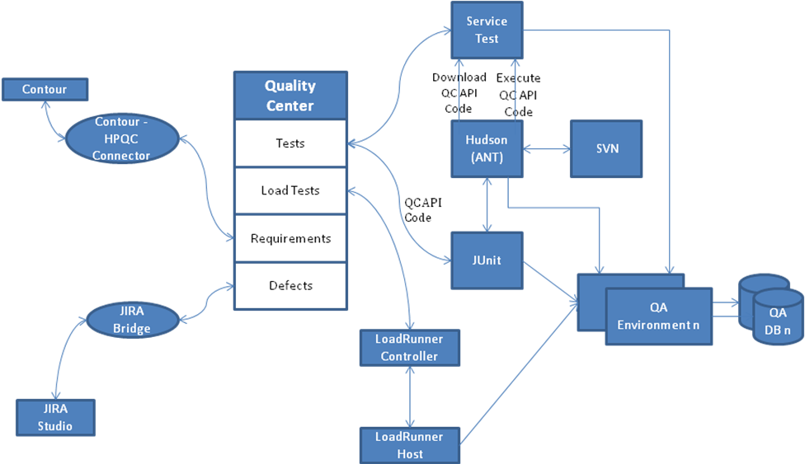

Test Management Tool Evaluation
A test management tool provides the QA Team with a central repository for designing test cases, executing tests, reporting/tracking defects, and publishing test metrics. The primary candidate tool for Test Management for caBIG is HP Quality Center (QC). QC is the premier test management tool in the marketplace. Due to its well-established position in the market, it provides two distinct advantages:
- QA resources with QC experience are readily available.
- Third party integrations with other SDLC tools are available.
A key objective for the caBIG project was traceability. QC provides traceability from the requirements to the test cases to the defects.

QC was evaluated to assure that it will meet the needs of the QA Team. The following actions were performed as part of the evaluation:
- QC was installed on an Amazon cloud instance
- Users and Project adminstartors were defined
- Sample requirements were defined in the Requirements Module.
- Releases were defined in the Releases Module and Requirements assigned to a Release.
- Sample test cases were written
- Sample tests were automated with HP Service Test
- Versioning

Functional Test Tool Evaluation
Functional Testing of webservices is complex. It is quite different from GUI-based testing. Typically, the main focus of webservices testing is to exercise all of the operation contained within each webservice. Usually this is done within from within a web application which uses the webservice operation. When used within a web application, the serialization/deserialization of objects to xml and xml to objects happens as part of the testing. This is shown in the following figure.

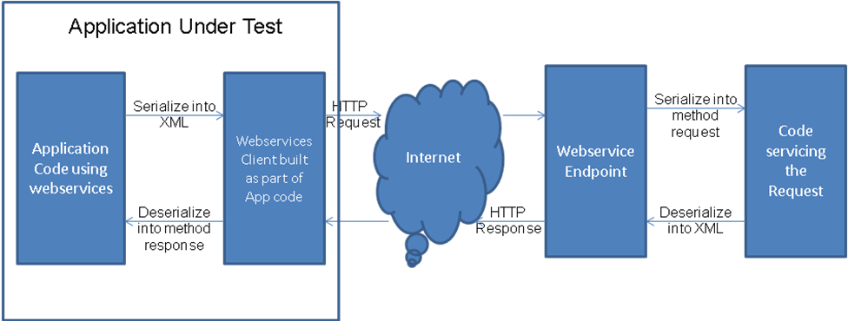

Since caBIG has no reference implementation, the webservices are being tested independent of any application. Therefore, our functional testing approach needs to cover both webservice operation testing as a well as serialization/deserialization.

Webservices Operations Testing
HP Service Test and SoapUI from Eviware are commercially available tools for functional testing of Webservices. Both of these fall into a category of tools referred to as “headless clients.” They operate at the XML request and response level and do not test serialization/deserialization of the XML into/out of code objects. The following figure shows how these tools fit into the webservices testing infrastructure.

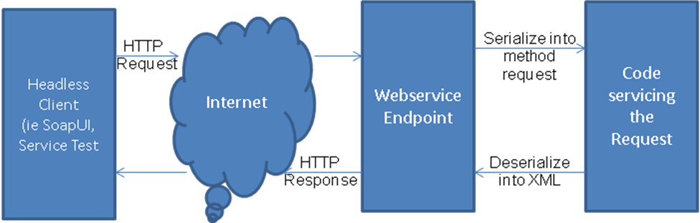

After evaluation of these two tools, the leading choice is Service Test because of its integartion with Quality Center. SoapUI would require the QA team to write a custom integration with Quality Center.
Issue – Service Test 9.5 evaluation does not support WSDL 2.0 and was unable to import the first WSDL that was delivered by Architecture. A Services Test 11.0 beta version is being provided to us by HP which is suppose to support WSDL 2.0
SoapUI has been used fairly heavily by the QA team pending the purchase of the selected toolset. SoapUI is able to import our WSDLs that are based on WSDL 2.0 but the tool often locks up (or is unworkably slow) because of the size of the resulting imported request.

Serialization/Deserialization Testing
As mentioned above, caBIG webservices are being tested independent of any application. To test serialization/deserialization of the XML, the QA team is also investigating additional testing approaches based on a Java Webservices Client and Junit test cases. The following figure shows how this tool fits into the webservices testing infrastructure.
- A prototype implementation of a Java-based programmatic (Junit) set of test cases is still being developed.
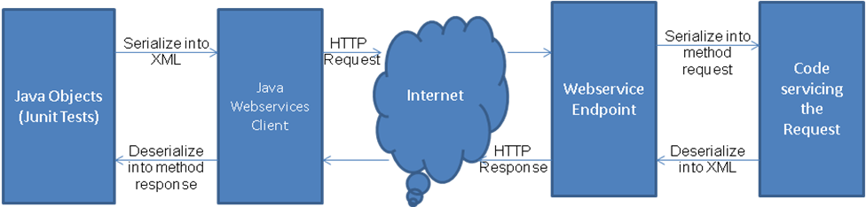

Performance Testing
The basic strategy during the first round of Component level performance tests is to identify the relative performance of each Service under a common set of load assumptions. Two categories of tests will be performed, benchmark and degradation tests. In this way we will be able to identify which services perform relatively well and those which perform poorly for a given set of load assumptions.

Subsequent rounds of Performance Testing will include Use Case testing for logically related Sets of Service/Operation calls and also Reference Implementation tests for the initial Deployment sites for caBIG services.

Scenario Design and Scripting
There are two categories of Performance Requirements we generally look for, Workload Expectations and then Response Time Expectations for that workload. The Workload Expectations usually reflect the expected transaction volume for the Services and the Response Time Expectations reflect the requirements for response times while the system is loaded with the expected transaction volumes. Since we don’t have those expectations yet, we will use a Benchmarking approach and a scaled Degradation approach. The Performance Test Plan will outline a Workload Characterization Matrix for each webservice.

LoadRunner test scripts will be developed for each Release/Iteration/Sprint using Service Test. Any functional test scripts developed in Service Tests will be leveraged to whatever extent possible with additional data variation to prevent server caching.
Service Test 9.5 evaluation does not support WSDL 2.0 and was unable to import the first WSDL that was delivered by Architecture. A Services Test 11.0 beta version is being provided to us by HP which is suppose to support WSDL 2.0. The initial LoadRunner evaluation was conducted using a WSDL provided by development which did not employ the complexities supported by WSDL 2.0.

Cloud Infrastructure
An evaluation license of the LoadRunner Controller was installed on a Windows instance in the Amazon cloud. The virtual users were hosted on the same instance for evaluation purposes. For QA testing separate cload instance will be required for the Controller and Virtual User Host machines.

Test Environment Provisioning
To get meaningful and realistic performance test results a test environment must be provisioned that is representative of deployment site infrastructures. The Perfromance Test Plan will outline the performance test environment requirements in terms of server hardware, OS, software configuration and database size.

Monitoring
LoadRunner provides a great many statistics related to transaction response time and server activity. Usually additioanal infrastructure monitoring is helpful and necessary to enable Development to effectively tune and debug perfromance issues. The Performance Test Plan will outline the performance monitoring that will be perfromed as part of the performance test execution.

When performance testing commences, the QA Team will work with the CDO Team to determine the monitoring options available within the Amazon cloud and with the Development Team to assure that informative monitoring is being perfromed.

Integration for Traceability

Traceability to Requirements
Quality Center provides a requirements module where the Analysis Team can design and develop requirements. The Analysis Team evaluated this tool along with other Rquirements Management tools and selected Contour from JAMA as their tool of choice. QA therefore evaluated a JAMA-provided Contour – QC integration tool. The following steps were performed to evaluate the integration.
- The integartion software was installed on a cload instance.
- Integration software was connected to a Contour demo project and a Quality Center demo project both on cloud instances.
- Mappings were done from Contour fields to Quality Center fields.
- Verified that field updates in Contour were propagated to Qulaity Center for new and existing requirements
- Verified that requirements could identified as belonging to a release

This integration allows the Analysis team to work in Contour and synchronize the requirements to Quality Center. Once the requirements are synchronized to Quality Center, the QA Team uses them to develop test cases. The traceability capability within Quality Center allows each test case to be mapped to requirement(s) and thereby show traceability and test case coverage.

Mappings for Release values are hard-coded in the mapping tool. Vendor committed to looking at more sophisticated ways of doing this based on the Releases defined in the Quality Center Releases Module.
Eval version of the integration did not support a Qulaity Center project with versioning turned on. Vendor committed to correcting this as part of deploying the software to us.

Traceability to Defects
The Development (ESD) team is using JIRA Studio as their primary work management tool. As such, ESD would like to have defects identified, worked and tracked within JIRA. The QA Team would like to use the Defect Module in Quality Center to to maintain traceablity in Quality Center between the requirement, test case and defect. The JIRA Bridge product from Orasi provides the capability to synchronize defects between Quality Center and JIRA. This allows a QA person to identify the defect in Quality Center to maintain this traceability. The developer has visability of the same defect in JIRA. Changes can be made to the defect and be seen in either tool.
- The following activities were performed as part of the JIRA Bridge evaluation.
- The JIRA Bridge software was installed by Atlassian as an approved plug-in for JIRA Studio
- The JIRA Bridge was connected to the JIRA Dev project and a Quality Center demo project.
- A defect was created in Quality Center and propagated to JIRA.
- Verified that a target JIRA project could be identified on the Quality Center defect and that the defect was propagated to the correct project in JIRA.
- Verified that defect comments were passed back and forth between QC and JIRA.
- Verified that individual field updates (ie. severity) were propagated properly in both directions in accordance with the defined field mappings
- Verified that propagation from JIRA to Quality Center could be restricted to just those defects that originated in Quality Center

- Defect have been entered directly into JIRA while the QA tool selection was progressing. CDO is investigating ways to do an initial “load” of defects from JIRA to Quality Center. This was not considered a pass/fail criteria of the evaluation.

Continuous Integration
A goal of the QA Team is to integrate an automated test suite into the build and deploy process. As described in the Functional Testing section, functional testing will be accomplished with both Service Test and a Junit implementation. This section will discuss the integration of each of these with the build and deploy process.

Service Test tests hosted in Quality Center
Functional tests Service Test will be hosted within test sets in the Quality Center Test Lab module. The method for integrating these into the build and deploy process is to execute a .bat file from the command line of an ANT script. The.bat file contains the Quality Center API code to execute a test set in Quality Center. The .bat file is written to reference the Quality Center test set(s) for the build and is checked-in to SVN as part of the build code.

JUnit Tests
The choice of writing tests in Java and using JUnit as a test framework fits neatly into the CI environment as it easily executes and publishes results . Standard Ant build scripts may execute JUnit tests. Since Ant is supported by the Hudson CI server that means a test run may be triggered automatically by a successful deployment of ESD code. Publishing of JUnit results is also natively supported by the Hudson CI server so we may be able to see the cumulative results of tests executed over time. The test framework may be extended to allow reporting back to QC although this may require additional development.

- Implementation of the Junit framework is still under development.
- Junit results will need to be integrated with Quality Center via the Quality Center API.

